EXPERIMENT 4 Design of an Experiment about Fundamental Operations with Voltages
GROUP NO: 2.3 Date: 28/12/2023

Objectives: In this experiment, analysis of a circuit which can perform the four fundamental operations which are addition, subtraction, multiplication, and division operations. The aim is to learn circuit analysis while performing these operations with operational amplifier circuits, Node-Voltage method and voltage divider equation.
Materials:
Breadboard
DMM (Digital multi-meter)
Signal Generator(s)
AC Power Supply
DC Power Supply
Oscilloscope
Resistor(s)
5 Terminal Op-Amps.
Switches

Procedure:

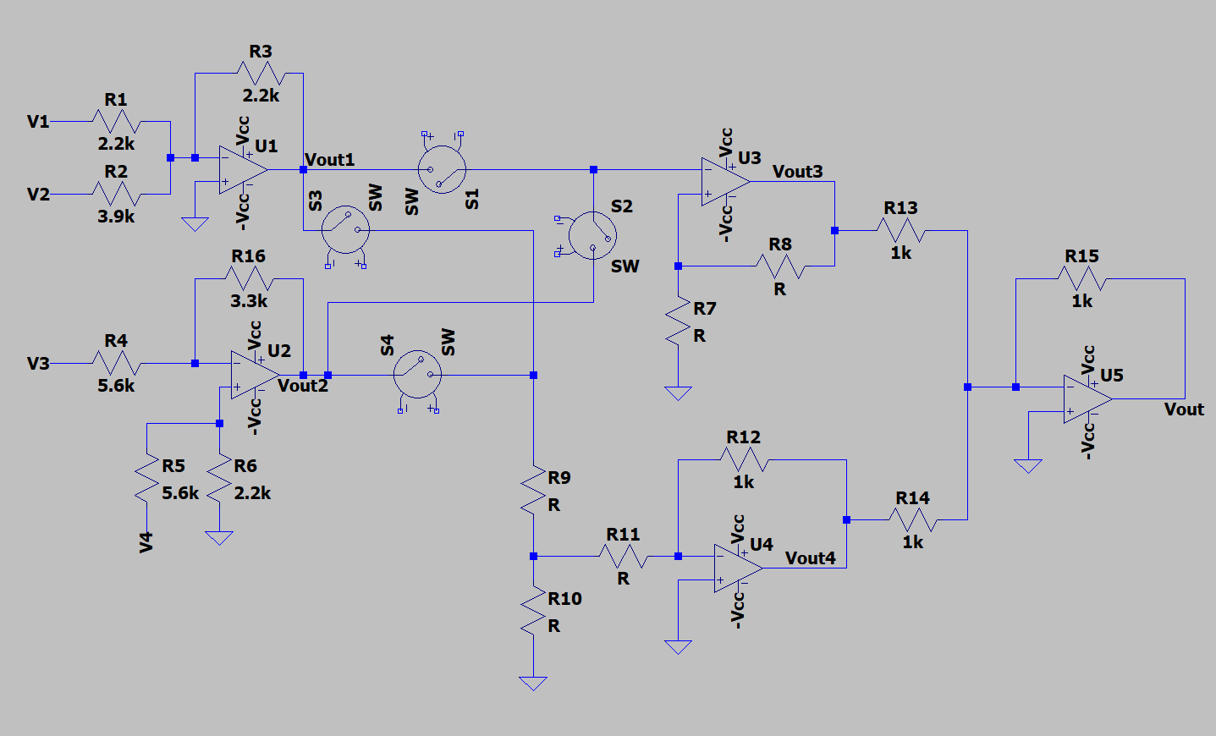

Marmara University, School of Eng., Electrical & Electronics Eng. EE 2001 Experiment 4 Page 1/3
GROUP NO: 2.3

Input 1(V1) : A sinusoidal signal having a peak to peak amplitude of 15 [V], and a frequency of 10 [kHz].
Input 2 (V2) : A DC signal having an amplitude of 5 [V].

Input 3 (V3): A triangular wave having a peak to peak amplitude of 20 [V], and a frequency of 100 [kHz].

Input 4 (V4) : A square wave having a peak to peak amplitude of 10 [V], and a frequency of 1 [kHz].

Q1) Inverting summation (U1) and subtraction (U2) amplifiers having two inputs is to be designed.

a) Determine the op-amp feeding voltages of U1 and U2 with respect to V_{out1} and V_{out2} values. (Use Node-Voltage Method).

b) Sketch output signals.

Q2) The U3 operational amplifier circuit is designed to multiply the input signal. What should be the values of R7, and R8 resistor values so that the value of V_{out3} is 4.9 times of the input signal? (Use Node-Voltage Method).

Q3) The U4 operational amplifier circuit is designed to divide the input signal. What should be the values of R9, R10 and R11 resistor values so that the value of V_{out4} is 1/3 of the input signal? (Use Node-Voltage Method).

Q4) The circuit is designed to perform the four fundamental operations which are addition, subtraction, multiplication, and division operations and any combinations of these operations using the input voltages.

a) Determine the value of V_{out} value using the Node-Voltage Method

i) For S1 and S4 switches are closed while S2 and S3 switches are opened?

ii) For S2 and S3 switches are closed while S1 and S4 switches are opened?

b) Sketch output signal.

i) For S1 and S4 switches are closed while S2 and S3 switches are opened?

ii) For S2 and S3 switches are closed while S1 and S4 switches are opened?

Marmara University, School of Eng., Electrical & Electronics Eng. EE 2001 Experiment 4 Page 2/3

GROUP NO: 2.3

Group Member 1: Abdussamed Şahin,150718017, Creating the circuit , 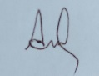

Group Member 2: Mehmet Ali Kamalak,150720062,Creating the question and circuit analysis 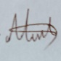

Group Member 3: Hüseyin Aydın Tokhan, 150719661, Creating the questions. 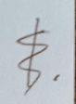

Group Member 4: Atakan Eroğlu, 150720827, Preparing the objectives and materials 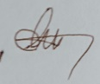

Marmara University, School of Eng., Electrical & Electronics Eng. EE 2001 Experiment 4 Page 3/3

